Jerry Olds  
1001533643  
IE-4378-001  
10/29/2019

Communications Needed for the Competition

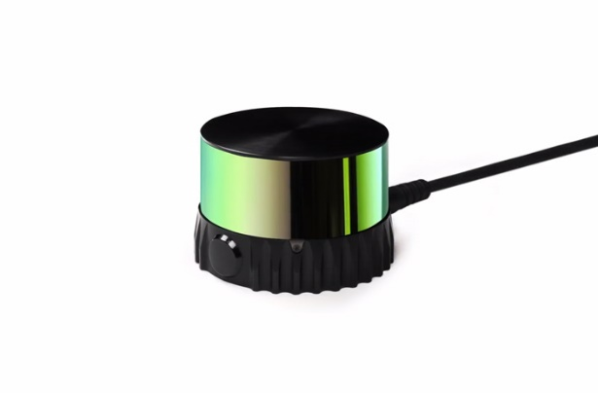

Ouster OS-1 Performance Lidar Sensor

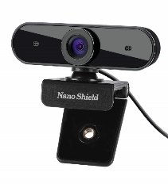

N910 Skype Web Camera Wide Angle

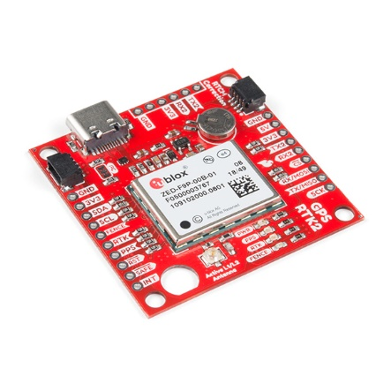

SparkFun GPS-RTK



ROS navigation stack takes readings from Lidar, GPS, and camera and based on those readings creates safe velocity outputs for the system. Implements partially autonomous communication form.